Les09-DML-insert etc

9-1 – p17 in pdf



OBJECTIVES of this topic

9-2

After completing this lesson, you should be able to do the following:

• Describe each data manipulation language (DML) statement

• Insert rows into a table

• Update rows in a table

• Delete rows from a table

• Control transactions – COMMIT SAVEPOINT ROLLBACK

Topics Covered

9-3

Adding new rows in a table

– INSERT statement

• Changing data in a table

– UPDATE statement

• Removing rows from a table:

– DELETE statement

– TRUNCATE statement

• Database transactions control using COMMIT, ROLLBACK, and SAVEPOINT

• Read consistency

• FOR UPDATE clause in a SELECT statement

DML – Data Manipulation Language

# What is it?

The SQL that manipulates data.

Data can be added, changed or deleted

A DML statement is executed when you:

– Add new rows to a table

– Modify existing rows in a table

– Remove existing rows from a table

• A *transaction* consists of a collection of DML statements that form a logical unit of work – such as inserting students registering

EXAMPLE:

Student comes in to pay for tuition

1) Decrease the amount owing to Seneca

2) Increase the total amount collected for the day

3) Store copy of activity (transaction) in a journal

4) Add it to the end of day check list

5) Print a receipt

NOTE:

Steps 1, 2, 3 and 4 must be completed before a transaction is complete. If any one of them fails then all actions must be undone.

ADDING A NEW ROW

9-5 graphic

9-6 SQL

**INSERT Statement Syntax**

• Add new rows to a table by using the INSERT statement:

• With this syntax, only one row is inserted at a time.

**INSERT INTO *table* [(*column* [*, column...*])]**

**VALUES *(value* [*, value...*]);**

Example: Inserting New Row

9-7

Insert a new row containing values for each column.

2ways

• List values in the default order of the columns in the table

.

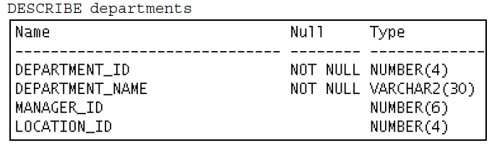

• Optionally, list the columns in the INSERT clause.

**INSERT INTO departments(department_id, department_name, manager_id, location_id)**

**VALUES (70, 'Public Relations', 100, 1700);**

Note: 4 columns in the INSERT and 4 values

• Enclose character and date values within single quotation marks.

Insert – with NULL values

Implicit method: Omit the column from the column list.

**INSERT INTO departments (department_id, department_name) 🡸**

**VALUES (30, 'Purchasing');**

🡺The specific columns were stated in the INSERT

Explicit method: Specify the NULL keyword in the VALUES clause.

**INSERT INTO departments**

**VALUES (100, 'Finance', NULL, NULL);**

There are 4 columns in the table and thee needs to be 4 columns in the VALUES clause

Special Values on INSERT

9-9

Put SYSDATE into 🡺 HIRE_DATE

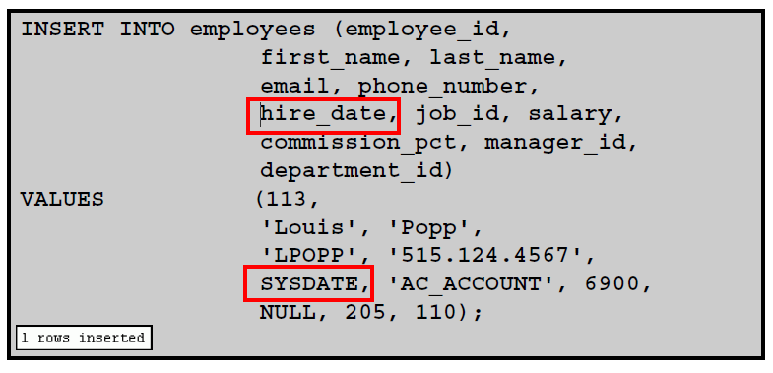

There are other functions like USER available to do the same thing

INSERT – with specific DATE and TIME

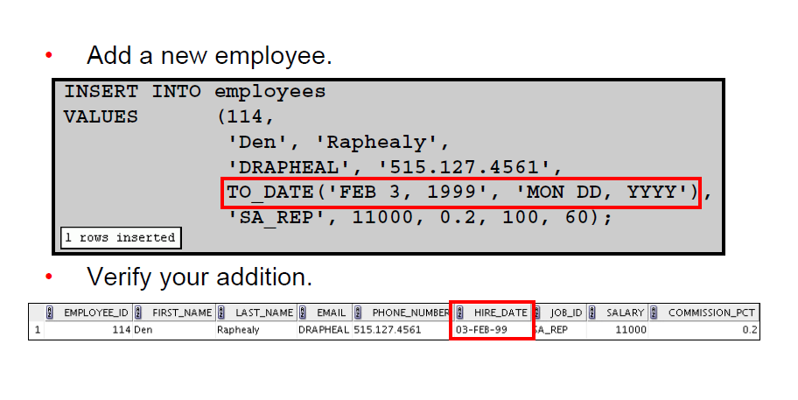

Might be preferable to use full century rather than let the system determine it with the RR for year

SCRIPT

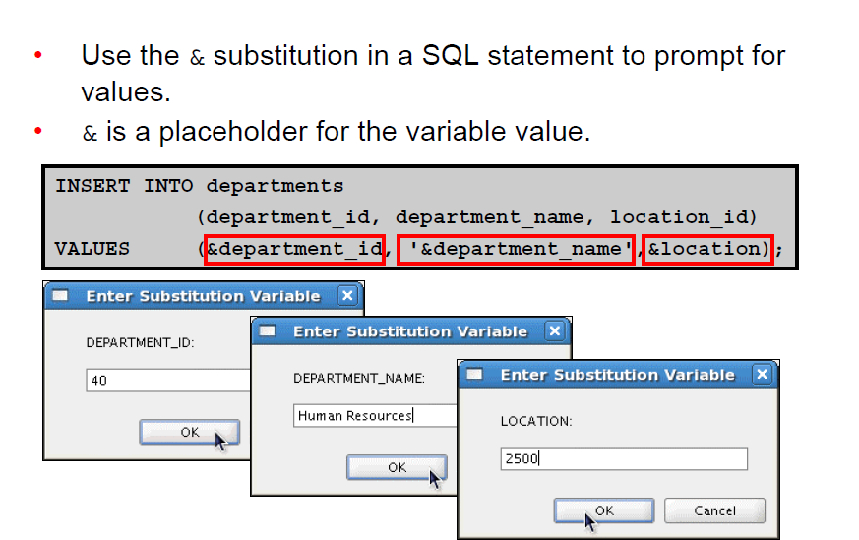

Can do script in a file and run it

INSERT – by COPYING FROM ANOTHER TABLE

9-12

Use a subquery

**INSERT INTO sales_reps(id, name, salary, commission_pct)**

**SELECT employee_id, last_name, salary, commission_pct**

**FROM employees**

**WHERE job_id LIKE '%REP%';**

NOTE:

🡺 No VAUES clause

🡺 Number of columns must match

🡺 Data type must match

EXAMPLE: of complete table

INSERT INTO EMPCOPY

SELECT *

FROM employees;

UPDATE – modify/change data

# Modify existing values

# Update 1 or more rows at a time

# Generic syntax

**UPDATE *table***

**SET *column* = *value* [, *column* = *value, ...*]**

**[WHERE *condition*];**

# Values for a specific row to change

**UPDATE employees**

**SET department_id = 50**

**WHERE employee_id = 113;**

# Change ALL rows – with no WHERE clause

**UPDATE employees**

**SET department_id = 110;**

# Update 2 items

**UPDATE employees**

**SET job_id = 'IT_PROG',**

**commission_pct = NULL**

**WHERE employee_id = 114;**

Updating Two Columns with a Subquery

# Update employee 113

# A) JOB ID SAME AS EMPLOYEE 205

# B) SALARY SAME AS 205

Method 1:

**UPDATE employees**

**SET job_id = (SELECT job_id**

**FROM employees**

**WHERE employee_id = 205),**

**salary = (SELECT salary**

**FROM employees**

**WHERE employee_id = 205)**

**WHERE employee_id = 113;**

Method 2:

**UPDATE employees**

**SET (job_id, salary) = (SELECT job_id, salary**

**FROM employees**

**WHERE employee_id = 205)**

**WHERE employee_id = 113;**

Updating - rows based on another table

9-18

# SUBQUERY

**UPDATE employees**

**SET department_id = (SELECT department_id**

**FROM employees**

**WHERE employee_id = 100)**

**WHERE job_id = (SELECT job_id**

**FROM employees**

**WHERE employee_id = 200);**

**What does this do?**

**Changes all employees that have a job_id the same as employee 200**

**🡺 to have the have the same department ID as employee 100**

So Far 1 Added data

2 Changed data

Next 3 Remove data

using

# DELETE

# TRUNCATE

DELETE statement

# Remove a specific row or rows

**DELETE FROM departments**

**WHERE department_name = 'Finance';**

**DELETE FROM employees**

**WHERE employee_id = 114;**

**DELETE FROM departments**

**WHERE department_id IN (30, 40);**

**Remove ALL rows**

**DELETE FROM employees;**

# Remove rows based on another table

**DELETE FROM employees**

**WHERE department_id =**

**(SELECT department_id**

**FROM departments**

**WHERE department_name LIKE '%Public%');**

Look in the department table for a department name that contains the string Public.

Use that rows department number and return it to the outer level statement

Delete rows in the employees table that has the same department number

TRUNCATE statement

# Removes ALL rows from a table, but leaves the table structure

**TRUNCATE employees;**

**WHY USE?**

**More efficient than DELETE**

**Delete checks all delete triggers**

**Truncate is a DDL statement and does nt create a copy to allow for ROLLBACK**

**If the table is the parent you need to drop constraint of the FK to do be able to do this**

COMMIT, ROOLBACK, SAVEPOINT

# Database transaction control

**Transaction example:**

**To pay tuition**

**1) Accept payment and reduce amount owing by student**

**2) Increase amount collected that day by be Seneca, to keep Seneca's book in order**

**A transaction is a series of statements forming an event**

**If any part of the series fails, need und all statements**

**Database Transactions: Start and End**

• Begin when the first DML SQL statement is executed.

- a statement that makes changes to the database

• End with one of the following events:

– A COMMIT or ROLLBACK statement is issued.

– A DDL or DCL statement that executes with an automatic commit

or

– The user exits SQL Developer or SQL*Plus.

– The system crashes.

**COMMIT and ROLLBACK Statements**

With COMMIT and ROLLBACK statements, you can:

• Ensure data consistency

• Preview data changes before making changes permanent

• Group logically-related operations

i.e. Gives you control over making changes to the data permanent

How it works

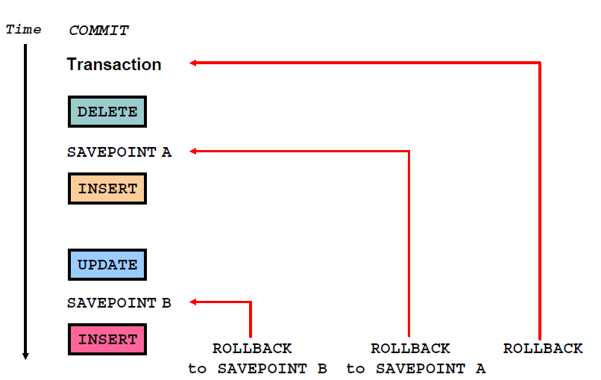

|  |  |
| --- | --- |
| COMMIT | Ends last transaction making the pending data changes before the commit to be permanent |
| SAVEPOINT name | SAVEPOINT *name* marks a savepoint within the current transaction |
| ROLLBACK | ROLLBACK ends the current transaction by discarding all pending data changes back to the last commit or the start of activity |
| ROLLBACK TO  *SAVEPOINT name* | ROLLBACK TO SAVEPOINT rolls back the current transaction to the specified savepoint, thereby discarding any changes and/or savepoints that were created after the savepoint to which you are rolling back. If you omit the TO  SAVEPOINT clause, the ROLLBACK statement rolls back the entire transaction. Because savepoints are logical, there is no way to list the savepoints that you have created |

Example:

**UPDATE...**

**SAVEPOINT update_done; 🡸 receive a message SAVEPOINT update_done succeeded**

**INSERT...**

**ROLLBACK TO update_done; 🡸 receive a message ROLLBACK succeeded**

(Note if create a savepoint with same name the previous one is deleted)

SYSTEM FAILURES

When a transaction is interrupted by a system failure, the entire transaction is automatically rolled back. This prevents the error from causing unwanted changes to the data and returns the tables to the state at the time of the last commit. In this way, the Oracle server protects the integrity of the tables

State of Data

# 1 Before a COMMIT or ROLLBACK

# - While making data changes (DML)

- The previous state of he data can be recovered

- The current state can be reviewed with the SELECT

- make changes then use a select to see the results

- Other users cannot see the effect of the DML changes

- Each user sees the state the data was in at the last commit

- Affected rows are locked

- Other users cannot change the affected rows

State of Data

# 2 After a COMMIT

- Data changes are saved in the database.

- The previous state of the data is overwritten.

- All users can view the results.

- Locks on the affected rows are released;

Those rows are available for other users to manipulate.

- All savepoints are erased.

Example: COMMITING data

9-35

# Make some changes –

**DELETE FROM employees**

**WHERE employee_id = 99999;**

**INSERT INTO departments**

**VALUES (290, 'Corporate Tax', NULL, 1700);**

# Commit the changes –

**COMMIT;**

**EXAMPLE 2:**

1 Remove departments 290 and 300 in the DEPARTMENTS table

2 Update a row in the EMPLOYEES table.

3 Save the data change.

1

**DELETE FROM departments**

**WHERE department_id IN (290, 300);**

**2**

**UPDATE employees**

**SET department_id = 80**

**WHERE employee_id = 206;**

**3**

**COMMIT;**

State of data after a ROLLBACK

Discard all pending changes by using the ROLLBACK statement:

• Data changes are undone.

• Previous state of the data is restored.

• Locks on the affected rows are released.

**DELETE FROM employees;**

**ROLLBACK;**

**State of the Data After ROLLBACK: Example**

**DELETE FROM test;**

**25,000 rows deleted. 🡸**

**ROLLBACK;**

**Rollback complete. 🡸**

**DELETE FROM test WHERE id = 100;**

**1 row deleted. 🡸**

**SELECT * FROM test WHERE id = 100;**

**No rows selected. 🡸**

**COMMIT;**

**Commit complete. 🡸**

**Statement-Level Rollback**

If a single DML statement fails during execution, only that statement is rolled back.

• The Oracle server implements an implicit savepoint.

• All other changes are retained and can be committed or rolled back

**Read Consistency**

• Read consistency guarantees a consistent view of the data at all times.

• Changes made by one user do not conflict with the changes made by another user.

• Read consistency ensures that, on the same data:

– Readers (SELECT) do not wait for writers

– Writers (INSERT, UPDATE, and DELETE) do not wait for readers

– Writers wait for writers

**FOR UPDATE Clause in a SELECT Statement**

• Locks the rows in the EMPLOYEES table where job_id is SA_REP.

**SELECT employee_id, salary, commission_pct, job_id**

**FROM employees**

**WHERE job_id = 'SA_REP'**

**FOR UPDATE**

**ORDER BY employee_id;**

• Lock is released only when you issue a ROLLBACK or a COMMIT.

• If the SELECT statement attempts to lock a row that is locked by another user, the database waits until the row is available, and then returns the results of the SELECT statement.

You can issue a NO WAIT as well so that it does not wait, but returns control to the user who can do other work. Without NO WAIT you could be waiting until the other users issues a ROLLBACK or COMMIT

EXAMPLES – FOR UPDATE

Using on multiple tables

**SELECT e.employee_id, e.salary, e.commission_pct**

**FROM employees e JOIN departments d**

**USING (department_id)**

**WHERE job_id = 'ST_CLERK‘ AND location_id = 1500**

**FOR UPDATE**

**ORDER BY e.employee_id;**

- Rows in both tables are locked

-

You can further qualify the UPDATE with a column name to restrict locking to only the table with that column in it

Example:

The following statement locks only those rows in the EMPLOYEES table with ST_CLERK located in

LOCATION_ID 1500. No rows are locked in the DEPARTMENTS table:

**SELECT e.employee_id, e.salary, e.commission_pct**

**FROM employees e JOIN departments d**

**USING (department_id)**

**WHERE job_id = 'ST_CLERK' AND location_id = 1500**

**FOR UPDATE OF e.salary**

**ORDER BY e.employee_id;**

WAIT EXAMPLE: Waits 5 seconds

**SELECT employee_id, salary, commission_pct, job_id**

**FROM employees**

**WHERE job_id = 'SA_REP'**

**FOR UPDATE WAIT 5**

**ORDER BY employee_id;**